**Assignment #5**

The data for this assignment is from the General Social Survey (GSS). The GSS collects data on modern American society in order to track and explain trends and constants in attitudes, behaviors, and attributes. The GSS is the best source for sociological and attitudinal trend data spanning the United States. It allows researchers to explore the structure and functioning of society in general along with the role played by relevant subgroups and to compare the United States to other nations.

This data examines different political views. First, male and female political views were examined using an unpaired T test because the two groups were separate. A Wilcoxon rank sum test was done to ensure that the data was not skewed.

There was no significance between male and females’ political views. The data was found to be normal, not skewed. When the data on political views was examined by gender nothing significant was found.

|  |  |  |  |  |  |  |  |
| --- | --- | --- | --- | --- | --- | --- | --- |
| **Table 1. Males and Females' Political Views** | | | | |  |  |  |
|  |  |  |  |  |  |  |  |
| Variable |  | Mean | S.D. | Var. | Min. | Max. |  |
|  |  |  |  |  |  |  |  |
| Men |  | 4.27 | 1.67 | 2.81 | 1 | 9 |  |
| Women |  | 4.20 | 1.67 | 2.78 | 1 | 9 |  |
|  |  |  |  |  |  |  |  |
| Note: p-value for Wilcoxon rank sum test was not statistically significant p=0.1096 | | | | | | | |
| Note: p-value for t-test was statistically not significant p=0.1724 | | | | | |  |  |
| Note: 95% confidence interval | | | |  |  |  |  |

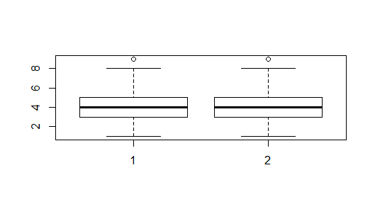

A contingency table was done to examine how many males and females identified within different party categories. According to the table, 55 males identified as other, 29 males identified as liberal, 425 identified as moderate and 451 males identified as conservative. For females, 81 identified as other, 362 identified as liberal, 607 identified as moderates and 477 identified as conservative.

|  |  |  |  |  |  |
| --- | --- | --- | --- | --- | --- |
| Table 3. Contingency Table: Males and Females' Political Views | | | | | |
|  |  |  |  |  |  |
| Variables |  | Other | Liberal | Moderate | Conservative |
| Male |  | 55 | 298 | 425 | 451 |
| Female |  | 81 | 362 | 607 | 477 |

Next, the data on political views was examined by ethnic group. There was no significance regarding the mean of the different ethnic groups. However, once the ANOVA was done to look at between group differences, a significant difference was found between the political views of Whites and Blacks. A box plot was also done to examine the data for normality. The data was found to be normal.

|  |  |  |  |  |  |  |  |
| --- | --- | --- | --- | --- | --- | --- | --- |
| **Table 3. Various Ethnic Groups' Political Views** | | | | | | |  |
|  |  |  |  |  |  |  |  |
| Variable |  | Mean | S.D. | Var. | Min. | Max. |  |
|  |  |  |  |  |  |  |  |
| Whites |  | 4.25 | 1.64 | 2.68 | 1 | 9 |  |
| Blacks |  | 4.11 | 1.7 | 2.89 | 1 | 9 |  |
| Other |  | 4.22 | 1.85 | 3.41 | 1 | 9 |  |
|  |  |  |  |  |  |  |  |
| Note: ANOVA f-value was statistically significant f= 1.479 | | | | | | | |

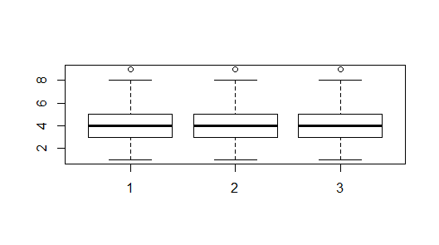

Lastly, a contingency table was done to examine how different ethnic groups politically identified. According to the table, most Whites identified as Conservative. While most Blacks identified primarily as Moderate. These are interesting finding as generally speaking most Blacks typically identify as liberal.

|  |  |  |  |  |  |  |
| --- | --- | --- | --- | --- | --- | --- |
| Table 4. Contingency Table: Various Ethnic Groups' Polictical Views | | | | | |  |
|  |  |  |  |  |  |  |
| Variables |  | Other | Liberal | Moderate | Conservative |  |
|  |  |  |  |  |  |  |
| Whites |  | 94 | 472 | 725 | 742 |  |
| Blacks |  | 29 | 114 | 207 | 116 |  |
| Other |  | 13 | 74 | 100 | 70 |  |